Research title: 3rd International Symposium on Carbon Materials (2027 ISCM-3) (Times New Roman, Font size 16)

Chun-Hu Chen¹, Wei-Ren Liu², Chih-Peng Li^{1*} (Times New Roman, Font size 12, Presenter please underline; Corresponding author please mark *)
¹Department of Materials Engineering, National University of Tainan, Tainan City 700301, Taiwan
²Department of Chemical Engineering, Chung Yuan Christian University, Taoyuan City, 320314, Taiwan (Times New Roman, Font size 10)
*Correspondence: president@mail.nsysu.edu.tw (Times New Roman, Font size 10)

Abstract. It is our great pleasure to welcome you to participate in the 3rd International Symposium on Carbon Materials (2027 ISCM-3) in Kaohsiung, Taiwan, from January 18 to January 22, 2027. With the theme of “Carbon Materials for a Sustainable Future,” ISCM-3 will provide an excellent platform for sharing cutting-edge knowledge, recent research findings, and advanced technologies across diverse areas of carbon materials. The symposium will focus on carbon materials for energy and sustainability, diverse carbon allotropes and architectures, and biofunctional applications. Distinguished plenary, keynote, and invited lectures will be arranged, together with oral and poster sessions, to promote meaningful academic exchange. Stimulating social programs will also be planned to provide extensive networking opportunities with outstanding scholars, researchers, and young scientists from around the world. Once again, we warmly welcome you to the 2027 ISCM-3 and Kaohsiung, Taiwan. https://2027-iscm-3.conf.tw/site/page.aspx?pid=901&sid=1697&lang=en (Times New Roman, Font size 11; One-Page Abstract (maximum 300 words); Format: including references and graphic abstract figure)
References (Times New Roman, Font size 11)
- Liu, Y.-P.; Tang, W.-R.; Liu, Y.-T.; Devi, Y.; Chiou, K.; Chen, C.-H. Cryogenic synthesis of crumpled graphene Spheres: Advancing scalability, stability and preserved chemical versatility. Carbon 2025, 242, 120435.
Graphic abstract (Times New Roman, Font size 11)
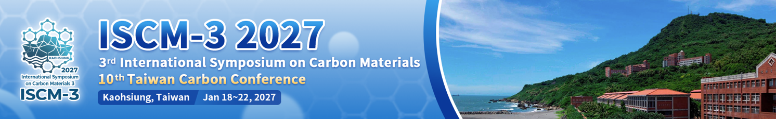

Figure 1. Schematic diagram of your research

